**Minor Project Report**

**Submitted in partial fulfilment of the degree of**

**Bachelor of Technology**

**By**

**MD.RAJ (23600122091)**

**SURAJIT MANDAL (23600121008)**

**SURAJIT ROY (23600121005)**

**TANMOY MODAK (23600122058)**

**SOUBIK DAS (23600122085)**

**SUMAN PRAMANIK (23600122083)**

**Fourth year student of**

**Greater Kolkata College of Engineering & Management**

 

**Under the supervision of**

Mr. Mainak Deb

**Sikharthy Infotech Pvt. Ltd.**

**Department of Computer Science & Engineering**

Date: 28th.Aug.2024

I hereby forward the documentation prepared by us **Md Raj, Surajit Roy, Surajit Mandal, Suman Pramanik, Tanmoy Modak, & Soubik Das** under the supervision of **Mr. Mainak Deb** Sir entitled **Result Management System Website/Portal** accepted as fulfilment of the requirement for the Degree of Bachelor of Technology (B.Tech) in **Computer Science & Engineering**  from **Greater Kolkata College of Engineering & Management** affiliated to **Maulana Abul Kalam Azad University of Technology** (**MAKAUT**).

|  |  |
| --- | --- |
| ______________________________    **Mr. Mainak Deb**  **(Senior Software Engineer & Project Manager)**    **Project Guide**  **Sikharthy Infotech Pvt. Ltd.** | ____________________________________    **Md Raj,**  **Surajit Roy,**  **Surajit Mandal,**  **Suman Pramanik,**  **Tanmoy Modak,**  **Soubik Das**  **Department of Computer Science & Engineering**  **Greater Kolkata College of Engineering & Management** |

**College Website/Portal**

By

**MD.RAJ (23600122091)**

**SURAJIT MANDAL (23600121008)**

**SURAJIT ROY (23600121005)**

**TANMOY MODAK (23600122058)**

**SOUBIK DAS (23600122085)**

**SUMAN PRAMANIK (236001220)**

UNDER THE GUIDANCE OF

**Mr. Mainak Deb**

**Project Guide**

**Sikharthy Infotech Pvt. Ltd.**

THIS IS SUBMITTED IN FULFILLMENT OF THE REQUIREMENTS FOR THE DEGREE OF

**B. TECH**

IN

COMPUTER SCIENCE & ENGINEERING

**GREATER KOLKATA COLLEGE OF ENGINEERING & MANAGEMENT**

**AFFILIATED TO**

**Maulana Abul Kalam Azad University of Technology**

[**Address**](https://www.google.co.in/search?rlz=1C1GTPM_enIN734IN734&biw=1366&bih=613&q=future+institute+of+technology+address&stick=H4sIAAAAAAAAAOPgE-LVT9c3NEyrMC-JTzbO0JLNTrbSz8lPTizJzM-DM6wSU1KKUouLAYQ6jCEwAAAA&sa=X&ved=0ahUKEwi3htjS0_rbAhVLQY8KHTJnC-kQ6BMI1wEwEQ)**:**Baruipur, near Phultala South 24 Paraganas -743387 West Bengal

[**Phone**](https://www.google.co.in/search?rlz=1C1GTPM_enIN734IN734&biw=1366&bih=613&q=future+institute+of+technology+phone&sa=X&ved=0ahUKEwi3htjS0_rbAhVLQY8KHTJnC-kQ6BMI6gEwEw)**:**9073683914 9073683915

**Email:** info.gkcem@jisgroup.org

**Website**: https://www.gkcem.ac.in/

**Certificate of Approval**

The foregoing project is hereby approved as a creditable study for the B.Tech in Computer Science & Engineering and presented in a manner of satisfactory to warrant its acceptance as a prerequisite to the degree for which it has been submitted. It is understood that by this approval the undersigned do not necessarily endorse or approved any statement made, opinion express or conclusion therein but approve this project only for the purpose for which it is submitted.

Final Examination for

Evaluation of the Project ----------------------------------------

-----------------------------------------

------------------------------------------

Signatures of Examiners

**ABSTRACT**

The purpose of the project entitled as “College Website/Portal” is to develop a webpage which is user friendly simple, fast, and cost effective. The college website efficiently manages various aspects of campus life, with a primary focus on storing and organizing student information. This features a dedicated section for accessing academic resources, where users can view or download relevant materials. Authorized administrators can effortlessly add, modify, or remove content through a user-friendly admin panel, ensuring seamless management of student data and resources.

**ACKNOWLEDGEMENT**

It is a great pleasure for us to acknowledge the assistance and participation of a large number of individuals to this attempt. Our project report has been structured under the valued suggestion, support and guidance of **Mr. Mainak Deb**. Under his guidance we have accomplished the challenging task in a very short time.

Finally, we express our sincere thankfulness to our family members for inspiring me all throughout and always encouraging us.

**Md Raj, Surajit Roy,**

**Surajit Mandal, Suman Pramanik,**

**Tanmoy Modak, Soubik Das**

**Department of Computer Science & Engineering**

**TABLE OF CONTENTS**

Chapter 1: Introduction

1: Introduction

Chapter 2: What We Have Used

2.1: HTML5

2.2: CSS3

2.3: FONT AWESOME

2.4: BOOTSTRAP

2.5:JAVA SCRIPT

Chapter 3: Functionality of the Website

3.1: Home Page

3.2: Anti Ragging Page

3.3: Courses and more

Chapter 4: FEATURES

Chapter 5: System Analysis

5.1: Identification of the need

5.2: Preliminary Investigation

5.3: Feasibility Study

Chapter 6: Project Planning and Scheduling

Chapter 7: Functional Requirement of the System

7.1: Hardware Requirement

7.2: Software Requirement

Chapter 8: Conclusion

Chapter 9: References

**INTRODUCTION :**

The College Portal is a comprehensive online platform designed to provide students, faculty, and all the users with a single-point access to all college-related information and resources. This intuitive portal enables users to effortlessly navigate and access various features, including academic details, syllabus, faculty profiles, affiliation information, and more. With just a few clicks, users can explore college news, events, and updates, as well as utilize online services, making it an indispensable tool for the college community to stay informed, connected, and engaged.

**2.1 Frontend**

In this project, we leveraged the powerful combination of HTML, CSS, Bootstrap, and JavaScript to create a dynamic and responsive web application. Through this development process, we gained hands-on experience with HTML structures, CSS styling, Bootstrap frameworks, and JavaScript functionalities. We explored various elements of web development, including HTML tags, CSS selectors, Bootstrap components, and JavaScript methods, allowing us to craft a robust and user-friendly interface. This project solidified our understanding of front-end development concepts, enabling us to effectively integrate these technologies to deliver a seamless user experience.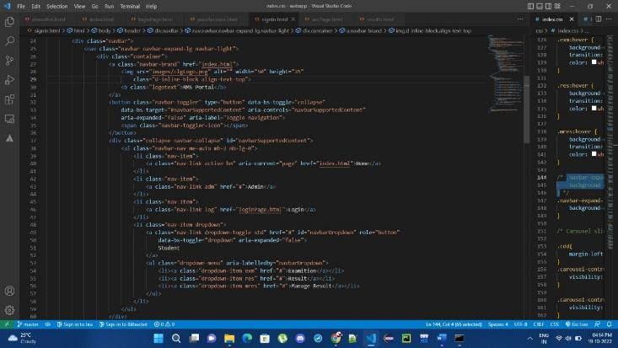

**2.3IDE**

We used Microsoft Visual Studio Code (VS Code) in our project as IDE.

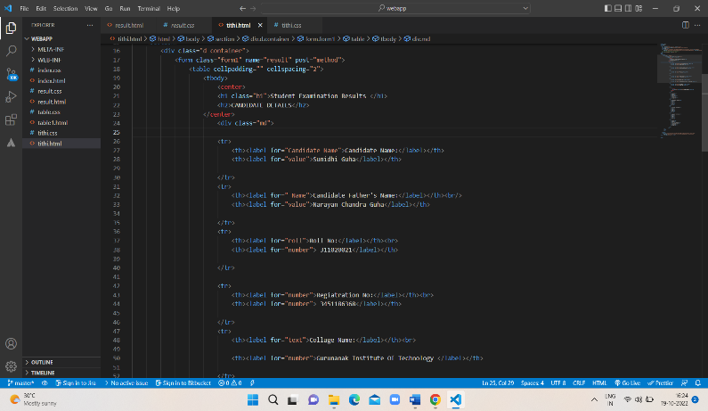

**3. FUNCTIONALITY OF THE WEBSITE**

**3.1 HOME PAGE**

This is the simple home page for the users. Users can explore all the other pages with just a few clicks.

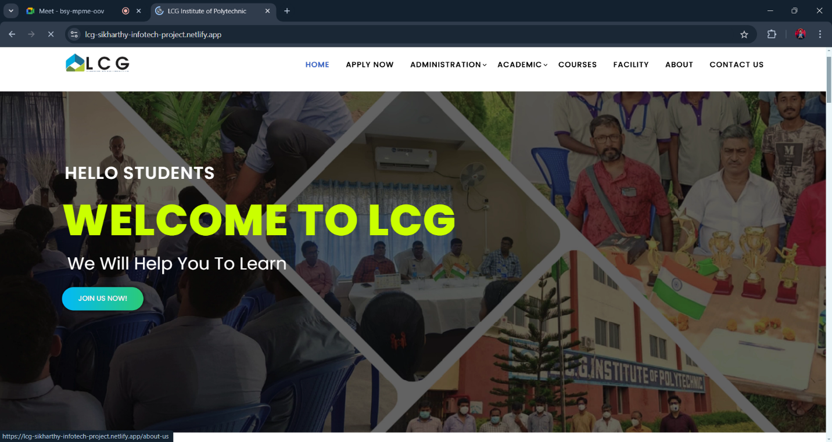

**3.2 ANTI RAGGING PAGE**

The Anti-Ragging page provides comprehensive information on the advisory committee, convenor, and members from civil and police administration, local media, student-faculty representatives, and parents, ensuring a safe and ragging-free environment.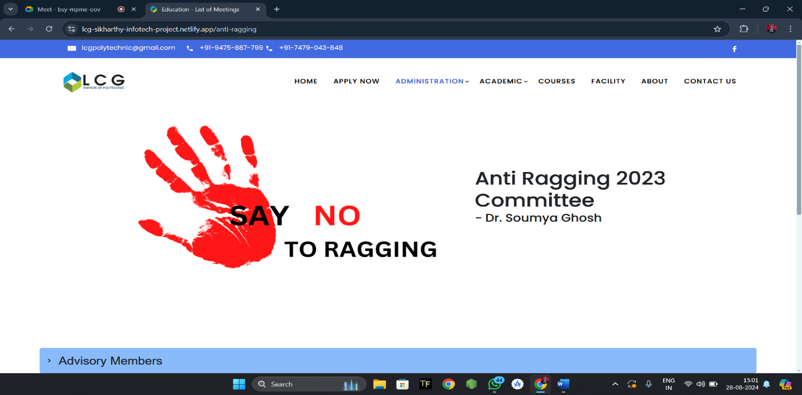

**3.3 COURSES PAGE:**

Our Courses page showcases a diverse range of academic programs, including Computer Science and Engineering, Mechanical Engineering, Civil Engineering, Basic Science, Humanities, and more, catering to various interests and career aspirations.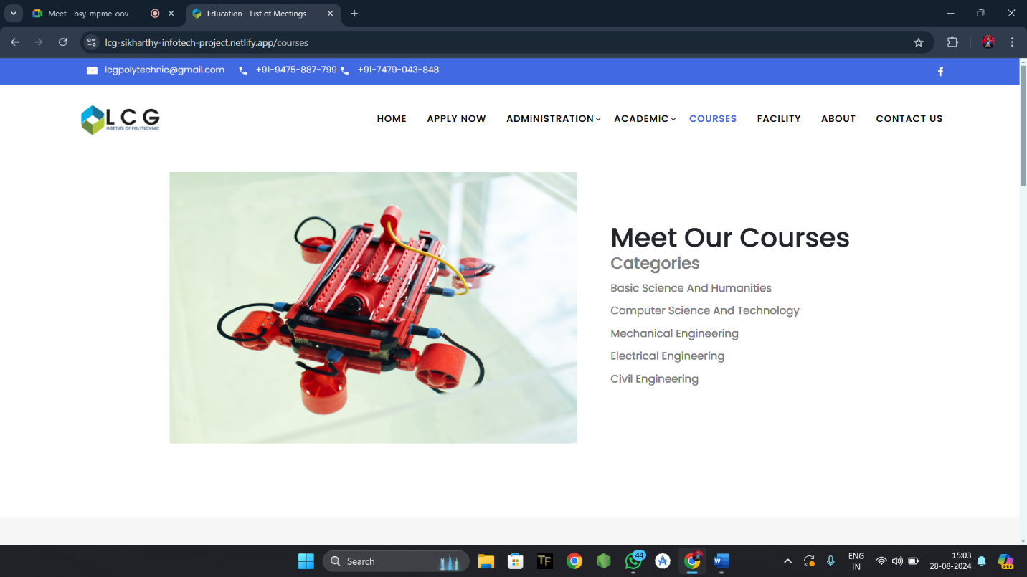

**3.5 About Us:**

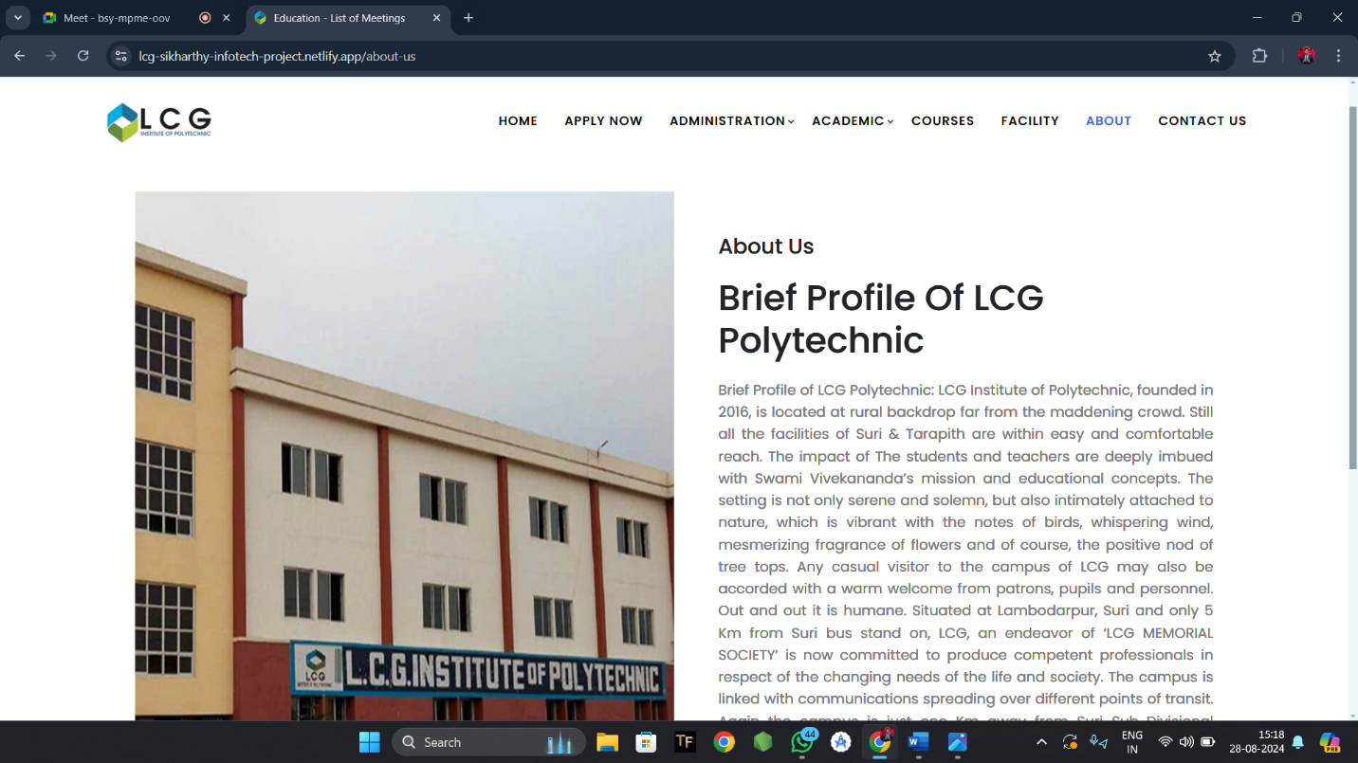

**3.6 Syllabus PAGE**

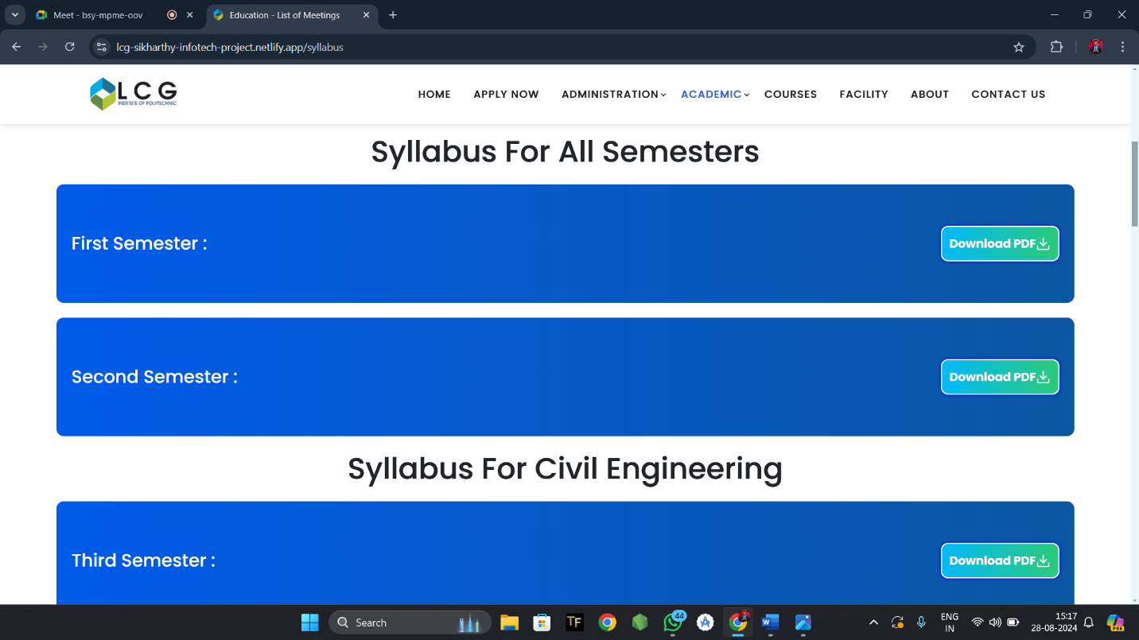

**3.7: Admission Page:**

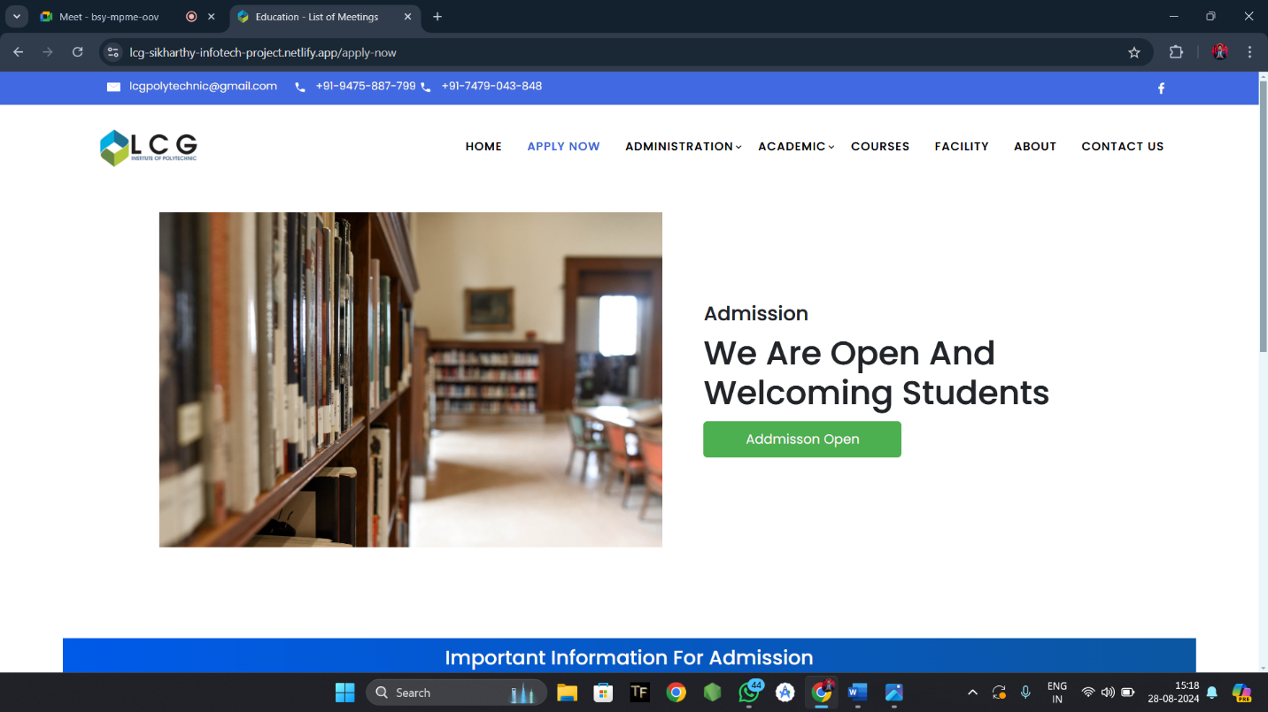

**3.8 : Facilities Page:**

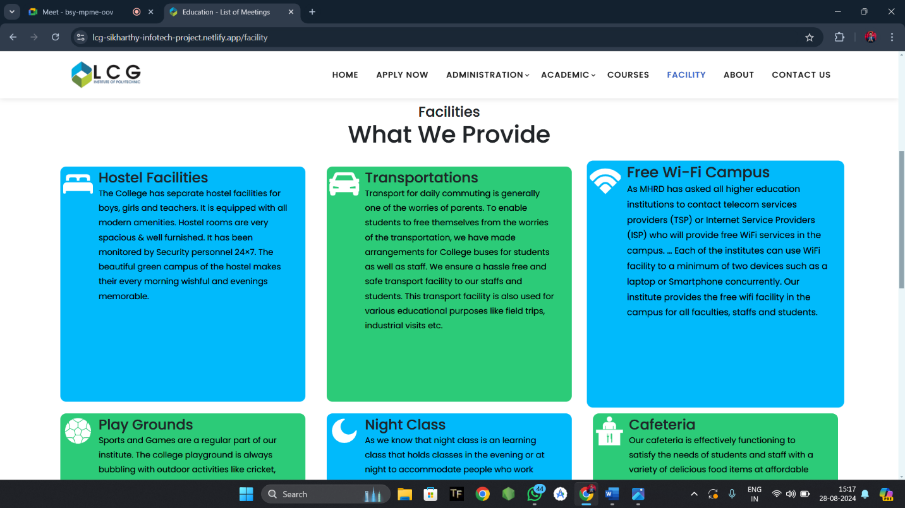

**4. FEATURES**

**-Easy Access to Information:** Students can access academic details, syllabus, faculty profiles, and college news with ease.

**- Online Resources:** Users can download study materials, and utilize other digital resources.

**- Event Updates:** Stay informed about college events, workshops, and seminars through regular updates.

**- Contact Directory:** Easily access contact information of faculty, staff, and administrative departments.

**5. SYSTEM ANALYSIS:**

**5.1 IDENTIFICATION OF NEED**

At the behind of any project, there are mainly two important parts i.e. Proper Plans and Right execution of those plans. This is the key of success. That will always help to execute the ideas.

Here that same process we followed during that development. We made the plan of making this **College Website** to make it easy for the users to access all the resources and stay updated.

**5.2 PRELIMINARY INVESTIGATION**

Preliminary investigations involve collecting information that helps to evaluate the merits of a project and make an informed judgement about the feasibility of the proposed project.

While we planned about **“COLLEGE WEBSITE”,** on the Internet a lot of consideration was given to all these issues. Extensive thought was given to the various minimum-offering levels that can be provided against the possible returns from such offerings.

**5.3 FEASIBILITY STUDY**

The feasibility of the project is analysed in this phase and business proposal is put forth with a very general plan for the project and some cost estimates. During system analysis the feasibility study of the proposed system is to be carried out. This is to ensure that the proposed system is not a burden to both the public and the company. For feasibility analysis, some understanding of the major requirements for the system is essential. Three key considerations involved in the feasibility analysis are:

**5.3.1 Economic Feasibility**

This study is carried out to check the economic impact on the system of the organization. The amount of fund that the company can pour into the research and development of the system is limited. The expenditures must be justified. Thus, the developed system as well within the budget and this was achieved because most of the technologies used are freely available.

**5.3.2 Technical Feasibility**

This study is carried out to check the technical feasibility i.e. the technical requirements of the system. Any system developed must not have a high demand on the available technical resources. This will lead to high demands being placed on the client. The developed system must have a modest requirement, as only minimal or null changes for implementing this system.

**5.3.3 Operational Feasibility**

The aspect of study is to check the level of acceptance of the system by the user. This includes the process of training the user to use the system efficiently. The user must not feel threatened by the system, instead must accept it as a necessity. The level of acceptance by the users solely depends on the methods that are employed to educate the user about the system and to make him familiar with it.

**6.Project Planning and Scheduling**

Scheduling is an important activity of any project management. Scheduling a software project involves first breaking down an entire problem into a logical set of tasks which would be assigned to developers.

In order to Schedule the “**COLLEGE WEBSITE**” we have to do the following:

▪ Identify the tasks needed to complete the project.

▪ Determine the dependency among different tasks.

▪ Establish the most likely estimates for the duration of the identified tasks.

▪ Plan the starting and ending dates for various tasks.

▪ Determine the critical path i.e. the chain of tasks that determine the duration of the project.

**7. Functional Requirement of the System**

Being a web-based solution the first and foremost thing that starts acquiring importance in this project is the way the complete package needs to be configured. Web-based solutions by virtue of their designs are mostly thin client solutions (unless they are heavy on DHTML). To run this kind of a solution properly it is necessary that the Server configurations are properly worked out. It is the server that will have to ultimately scale up as and when the numbers of users start increasing.

**7.1 HARDWARE REQUIREMENTS**

The minimum Hardware requirements for the application to run smoothly should have the following configuration:

|  |  |
| --- | --- |
| **Processor** | Intel Core i3 |
| **RAM** | 4GB or more |
| **HDD** | 3GB or more |

**7.2 SOFTWARE SPECIFICATIONS**

The minimum software requirements are as follows:

|  |  |
| --- | --- |
| **Operating System** | Windows 7,8 and upwards |
| **User Interface Design** | HTML, CSS, BOOTSTRAP, JS |
| **Web Browser** | Mozilla, Google Chrome, OPERA |
| **Working IDE** | Visual Studio Code |

**9. CONCLUSION**

In conclusion, our **“College Website”** is a dynamic and user-friendly platform that serves as a one-stop destination for all college-related information and resources. With its robust features and easy navigation, it aims to enhance the overall college experience for students, faculty, and staff. Whether you're looking for academic details, college news, or online resources, our website has got you covered. We continuously strive to improve and update our website to meet the evolving needs of our college community, ensuring a seamless and engaging online experience.

**10.REFERENCES:**

1. https://www.w3schools.com/
2. <https://www.codewithharry.com/>
3. <https://www.javatpoint.com/>
4. <https://www.openai.com/>
5. https://www.microsoftcopilot.com/